**Project Proposal**

**Mathew Poelvoorde**

**July 23, 2017**

**PART 1: TOPIC AND SCOPE**

The scope of this project is to make a website for a hypothetical hotel business located in Windsor, Ontario, called Vacation Inn. The website will have three levels of access: one for potential customers, one for hotel receptionists, and one for managers. Customers are defined as people that use the site for browsing and booking hotel rooms. Receptionists are defined as people who use the website for booking rooms for walk-in guests. Managers have full control of almost the entire website, and have the exclusive authority to offer any type of room discount, implement any type of temporary price increase (for example, if a local event is expected to increase demand for hotel rooms), and add any receptionists to the database.

The hotel will have three types of rooms: standard, deluxe, and suite. A standard room has one double bed and a basic bathroom with a basic bathtub. A deluxe room has two double beds, and a more luxurious bathtub with massaging jets. A suite has two separate one-bed rooms, and a top-of-the-line bathtub, along with deluxe cable and unlimited Wi-Fi.

**PART 2: USE CASES AND PRIVILEGE LEVELS**

**Customer:**

The customer enters the website and is presented with a home page with basic details about our business. The customer may use the navigation bar to navigate the website. Links in the navigation bar allow users to browse hotel rooms, contact a manager (via email), or view past and current bookings.

Upon clicking on the link to browse hotel rooms, users are asked which date they intend to begin their stay and how many nights they intend to stay for. Listings for rooms available for the entire duration of the customer’s intended stay are listed. Users may filter results by room type, price, smoking/non-smoking preference, and occupancy. Users may click on each room to view details about each room. They will also be presented with an option to add the room to the cart, which requires the user to log in or make an account. This is done via a separate page that redirects the user to the room page when logged in and adds the room to the cart. The user then may then add more rooms if s/he chooses, or click on the cart for checkout.

To checkout, the user is already presumed to be logged in. That’s because adding a room to the cart requires a login, and you need to have at least one room in the cart to check out. The system will ask the user for his/her credit card information, and, after that is confirmed, the customer will be charged and the room(s) added to the “booked rooms” table.

If a user wishes to cancel after booking, s/he may do so by clicking on the “My Reservations” tab on the home page and logging in if not currently logged in. The reservations currently made by the user are listed. The user clicks on the reservation to cancel it, and is told how much of the reservation is non-refundable (a 25% cancellation fee applies). If the user agrees with the cancellation terms, the reservation is cancelled. Reservations cannot be cancelled after 11:59 pm the night before the reservation starts.

**Receptionists:**

A receptionist has the authority to book rooms for walk-in customers. If a customer walks in asking for a room, the receptionist should ask how many nights they need a room for, and whether they need smoking or non-smoking. They should also select the room type, but only after explaining the room types to the potential guest and verifying what type of room they want. It is assumed that the reservation will start the current night, as reservations for future dates must be made online.

After given this data, the receptionist is given the list of rooms available that match the given parameters, and selects a room they think the guest would like. If the guest agrees, the receptionist asks for the guest’s name and will be returned any records in the customer table that match that name. If no records exist, the receptionist will create a customer profile for that guest; otherwise, the receptionist selects that profile. The customer then pays for the reservation using a credit card, and the reservation is added to the reservations database and confirmed.

**Managers:**

Managers have the authority to implement temporary price increases or decreases for any room type on any given date for any reason. For example, they may decide that, due to anticipated demand, standard, deluxe, and suite rooms need to be increased by $20, $40, and $100, respectively, from August 1 to 15. To prevent pricing inconsistencies, any price increase or discount must be made for all three room types simultaneously, and only in $5/$10/$25 increments. Managers also have the authority to permanently increase/decrease the “basic” (non discounted/surcharged) price of any room type or individual room.

A manager may register any person as a receptionist or a manager, by assigning them a username and temporary password.

**PART 3: QUERIES**

The website and database need to be designed to answer many questions that the users (customers or managers) may have about the hotel. Here are some common queries that the website will be able to accommodate:

1. **What is the most popular room?** The results screen shown to users will always show the most popular results first, ordering by the number of times the room has been rented in the past.
2. **What is the most expensive/cheapest room available?** Alternatively, the user may instead order by price (ascending or descending).
3. **What rooms are available that are currently unreserved from [date] to [date]?** The website will automatically only show rooms with no reservations between the dates the user specifies.
4. **Which rooms permit smoking?** Users may choose to filter rooms by smoking or non-smoking.
5. **Which rooms are standard/deluxe/suites?** Users may choose to filter results by room type.
6. **Which rooms have one or two beds?** Users may filter results by number of beds in the room. Note that all of the hotel’s beds are queen beds, but some rooms have one bed and some two.
7. **Which rooms are suitable for occupation by a certain number of people?** Results can be filtered by occupancy rate (1, 2, 3, or 4 people) instead. For example, standard rooms would be excluded from a search query for a room for 3-4 people, since 3 or more people cannot fit in one bed. All three room types are suitable for two people (they might want to sleep in different beds, or share one bed), and only standard rooms would show in a 1-person query (since who needs two beds for one person?).
8. **Can a user book multiple rooms?** The website allows for the booking of more than one room at the same time, in case customers need accommodation for more than 4 people. However, only three rooms can be reserved at a time.
9. **Can a user view which rooms s/he has reserved?** A user can view the rooms they’ve reserved in the My Reservations section of the website, and cancel future bookings up to the day before the stay (subject to a cancellation fee).
10. **What is the overall occupancy rate by room type?** Managers may use this data in order to permanently increase/decrease prices if rooms are booked too often/not often enough.
11. **What is the occupancy rate for smoking rooms vs. non-smoking rooms?** Managers may use this data to designate more/fewer smoking rooms in the future.
12. **Which rooms have been booked tonight?** Managers can all bookings in the hotel for a specified date. This data could be helpful if managers need to call in additional staff on busy nights.
13. **What is the total monthly revenue?** Managers may use this data to determine room prices, or whether to advertise more often, etc.
14. **What is the year-over-year revenue?** Managers can use this data to determine if sales are trending in the right direction, and this comparison, unlike query 15, is unaffected by seasonal variations in hotel stays.
15. **Who are the best customers?** Managers can determine which customers have stayed most often in the hotel. This data can be used by managers to potentially offer incentives for those customers to continue to stay at Vacation Inn in the future.

**PART 4: DESIGN AND ACCESSIBLITY**

Examples of how my web page would look are included on a separate file attached to this report. I apologize that I couldn’t make my scanner properly read my artwork. To ensure accessibility, the navigation bar has a separate look on mobile devices with larger buttons that are easier to touch. The use of jQuery Mobile will be considered to simplify the process of making the website responsive to mobile/desktop needs. To ensure appropriate color differentiation for color blind users, and an appropriate look for all other users, I have decided to use a blue/light brown color scheme for the website, since these colors might remind users of blue skies and sandy beaches. After all, I want customers to feel like they’re on vacation at Vacation Inn! When another color is needed, a grassy-colored green is used. Further, it should be noted that a mobile-specific view is only provided for customers, as receptionists and managers should only be doing their work on a computer, not a phone.

**PART 5: DATABASE DESIGN**

Here is the design of the database. The database is called poelvoo_fp, where “poelvoo” is my University of Windsor username, and “fp” stands for “final project”.

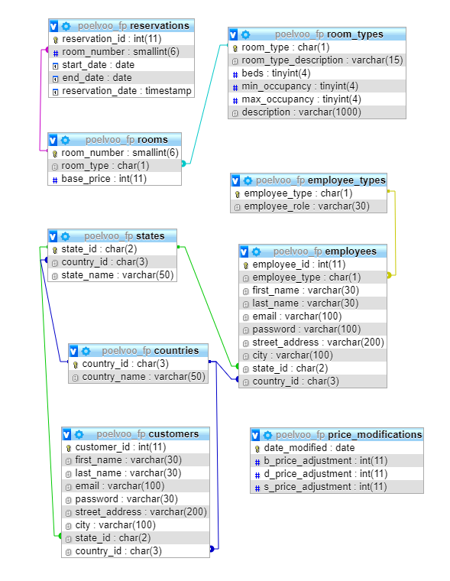

The database has seven tables in total. These tables are described below, in the order they are inserted into the database:

* **Countries:** The countries table exists so that users cannot register as customers using fake countries. Instead, every known worldwide country would be entered into the database and users would choose their country of residence from a drop-down menu. The three-letter country_id is used to minimize storage space (for example, “Canada” would have country_id “CAN” in my database). Since I don’t have time to manually input 200 countries into the database, only a handful will be used on my website for testing purposes.
* **States:** The states table is only used for U.S. and Canadian registrants. It would normally contain all 50 states, 10 provinces and 3 territories, except that due to limited resources, it will be limited to Michigan (with state_id “MI”), Ohio (OH), New York (NY), California (CA), Ontario (ON), Manitoba (MB), and Quebec (QC) initially. The country_id is used to determine if the state is in the U.S. or Canada.
* **Customers:** This table is used to store detailed data about each customer. Walk-in customers won’t have an email or password inserted into the database, since they don’t have an online account.
* **Room_types:** The room_types table is used to store data about the three types of rooms in the hotel. Each room type has a one-letter code used to identify it: standard (b), deluxe (d) and suite (s). The reason standard is abbreviated “b” is to avoid name conflict with suite, which is already abbreviated “s”.
* **Rooms:** The rooms table stores data about each room in the database, including its room type and base (unadjusted) price.
* **Reservations:** The reservations table stores data about each reservation, including when it begins and ends, when it was made, and which customer booked it.
* **Price_modifications:** This table stores temporary price modifications by date. If a price modification lasts for more than one day, it is inserted into the database once for each day of the modification, to make searching for prices by date easier. There are three types of modifications, one for standard (basic) rooms, one for deluxe rooms, and one for suites, denoted b_price_adjustment, d_price_adjustment, and s_price_adjustment respectively. If another room type is needed in the future, another column would need to be added to this table.
* **Employee_types:** Stores codes for either receptionist (“r”) or manager (“m”)
* **Employees:** Stores the list of employees, with roughly the same attributes as customer.

The relationships between tables are as follows:

* Each state belongs to exactly one country. Each country has zero or more states. As such, country to state is a one-to-many (1:N) relationship.
* A customer must belong to exactly one country and may belong to exactly one state. A country may host many customers, and so may a state. Thus, state:customer and country:customer are both 1:N. Similarly, employees are subject to the same state/country restrictions as customer and those must be 1:N as well.
* A room may be reserved many times, and a reservation must be for exactly one room, making room:reservation a 1:N relationship. The reason that multiple-room bookings are entered into the database multiple times is to avoid a many-to-many relationship here, and allow for the cancellation of individual rooms of a reservation.
* A room type can be associated with many rooms, but a room must have exactly one room type. This makes room_type:room a 1:N relationship.
* An employee must have exactly one employee type and an employee type could belong to zero or more employees. Thus employee_type:employee is 1:N.

Some additional things to note about my database design are as follows:

* Users can book one or more rooms for a period of 1 to 7 nights at a time. If a user books multiple rooms, each room is treated as a separate booking in the database to ensure that the primary key in the reservations table is simply an automatically generated “booking ID”. Because of this, users have the option to cancel one room at a time instead of an entire reservation if they wish.
* In the initial design, it is assumed that higher floors have better “views” and are more worthy of higher prices. Initial room prices will be set to $89/$139/$249 for standard/deluxe/suite rooms, plus $5/$10/$25 per additional floor above the second. Smoking rooms have a $20/$40/$75 premium. There are 5 total floors, and only the second floor permits smoking. Each floor has two standard rooms, two deluxe rooms, and one suite. Managers have complete discretion to raise/lower prices for individual rooms, or raise base prices by a certain amount for all rooms of a certain type. Room prices are set as **integers**, and must be adjusted in whole-dollar increments. Taxes are not included in room prices, since those can be easily calculated from the room price.
* The floor each room is on can be derived from the room number and is not stored. The first digit of the room number is the floor number. The first floor is used for amenities (e.g. indoor pool) and office space, and as such has no rooms.

**PART 6: REPORTS**

The types of reports that can be generated for managers have already been discussed in the “queries” section. These include queries 10 to 15 of that section.

**PART 7: TESTING AND ADMINISTRATION**

There are many steps that are necessary to ensure consistent and efficient operation of the website. These include:

* A file naming convention similar to that used in class. All names are lowercase, to ensure compatibility with all systems, and the folder structure is named like this:
  + /60-334/project/**user-level**/**file-type**/**file-name**

where:

* **user-level** is either empty for public access, “reception” for files exclusively accessible for receptionists, or “manager” for files exclusively accessible for managers
* **file-type** is either HTML for HTML or PHP files, CSS for CSS files, or JS for JavaScript files
* **file-name** is the name of the file itself
* Seeding the database with sample customers and bookings to ensure the database works as intended
* Designing and testing the website on a mobile phone and a desktop computer (I don’t own a tablet, so I can’t test my website for tablet devices), as well as multiple browsers on each device